Title: Retail Sales Analysis

Purpose:

As a Data Analyst at an e-commerce company, I focus on driving smarter sales strategies and improving customer satisfaction. The purpose is to identify what's working and what can be the improvements in it, helping the business grow more effectively and better serve our customers.

My current project involves the following themes:

- Sales trends: I look at how our sales change over time to spot patterns and future plan.
- Customer behavior: I study how people shop on our site to understand what they like and how they make buying decisions.
- Product performance: I check which products are doing well and which ones need more attention.
- Geographical insights: I explore where our customers come from to see which areas are driving the most sales.

Actual Data:

This data is before the fixing/cleaning. There are 541909 rows and 9 columns. The columns include:

- InvoiceNo: Unique identifier for each transaction
- StockCode: Product/item code
- Description: Product description
- Quantity: Number of items purchased
- InvoiceDate: Date and time of transaction
- UnitPrice: Price per unit in GBP
- CustomerID: Unique identifier for each customer
- Country: Country of the customer

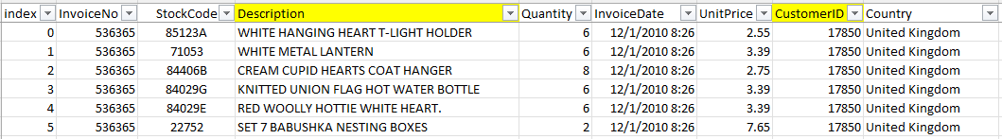

There are some blank rows in Description and CustomerID which needs attention and there are few more cleaning required in other columns as well.

I have followed the steps below to make the Dashboard out of this dataset.

Data Cleaning:

- Removed blank rows in description column, it doesn’t have any Unit Price.
- Removed incorrect invoice No., description, quantity with -ve number.
- Extracted time from InvoiceDate.
- Data types corrected for all the columns.

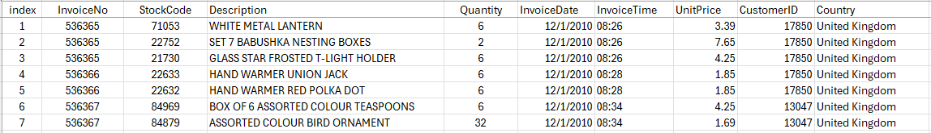

Data Processing:

- Added Revenue column
- Added Day of week column

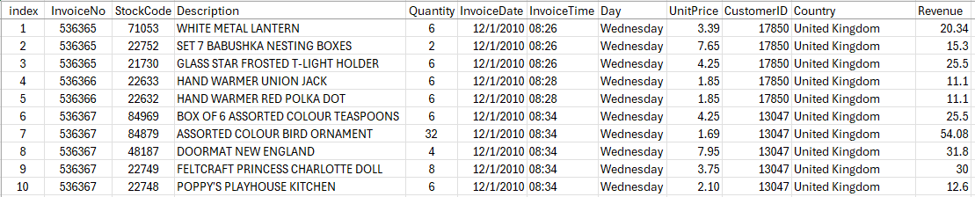

Data Analysis:

To visualize key trends, I created pivot tables on a dedicated sheet and built charts from them.

The first line chart illustrates the monthly revenue, providing a clear view of sales fluctuations over time.
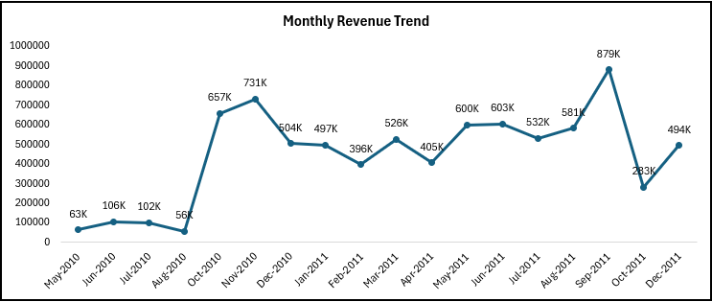

After that I have created top 10 charts in each category of Countries by product sold, top products by quantity and revenue and then top countries by revenue.

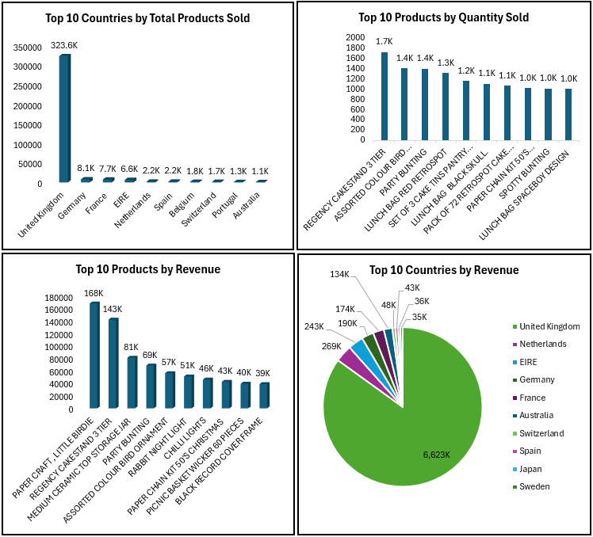

After this we have Sales performance by day of the week. Along with that showing of comparison of avg. unit price by price sensitivity.

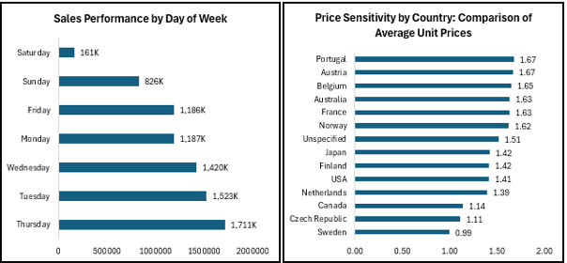

Towards the end, we highlighted the monthly transaction trend using Stock ID data. Additionally, seasonal trends based on quantity sold are also presented to showcase demand patterns throughout the year.

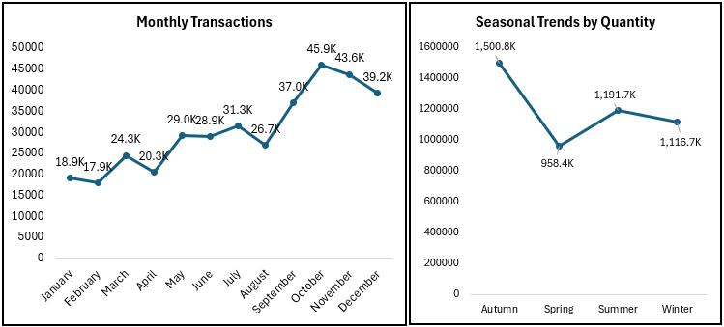

Insights:

Customer Behavior - Shows how customers are buying
- On average, each customer brings in 67.3 in revenue.
- Around 98.2% of customers come back to make another purchase, which means most of them are happy with their experience.
Product performance - Highlights the most popular items.
- The best-selling product is ‘Paper Craft – Little Birdie’, earning 168K in revenue.
- The second best is ‘Regency Cake Stand’, which made 143K.
Sales Over Time - Shows how sales change by month and season.
- October had the highest number of transactions (45.9K), while January had the lowest (18.9K).
- Sales are highest in Autumn with 1.5 million units sold, and lowest in Spring with 958K.
Country-Wise Sales - Shows which countries bring in the most money.
- Since the company is based in the UK, it has the highest sales (6623K), followed by Netherlands (269K).
Pricing and Efficiency - Looks at prices and how much is sold per order.
- The average unit price is 1.68.
- Sweden is more price-sensitive, with a lower average price of 0.99 compared to other countries.

Recommendations:

- Promote Best-Selling Products:
Products like ‘Paper Craft – Little Birdie’ and ‘Regency Cake Stand’ are performing well. Highlight these in marketing campaigns or bundle them with other items to boost overall sales.

- Prepare for Seasonal Highs and Lows:
With October and the Autumn season bringing in the most sales, ensure stock levels, staffing, and promotions are ready ahead of time. Plan special offers during slower months like January and Spring to improve sales.

- Expand in High-Potential Markets:
The UK leads in revenue, but countries like the Netherlands and others show potential. Consider targeted marketing or localized offers to grow sales in these regions.

- Adjust Pricing for Sensitive Markets:
Countries like Sweden are more price sensitive. Explore offering lower-priced options or discounts in such regions to stay competitive without affecting profits.

Report Compilation:

The analysis and visualizations have been compiled into a well-structured report, organized into key sections for clarity and ease of interpretation.

